

**UNIVERSITY OF PETROLEUM & ENERGY STUDIES**

**Dehradun**

# Docker

**Experiment**

**Name: Harshil Bhardwaj**

**Course: B. TECH CSE DevOps (2018-22)**

**Roll no.: R171218045**

**Sapid: 500068580**

**Experiment- 7**

**Create Docker Swarm Cluster**

1. Initialize the swarm using the command

$ docker swarm init

Now run the command shown in the output in the other terminal to appoint it as a worker.

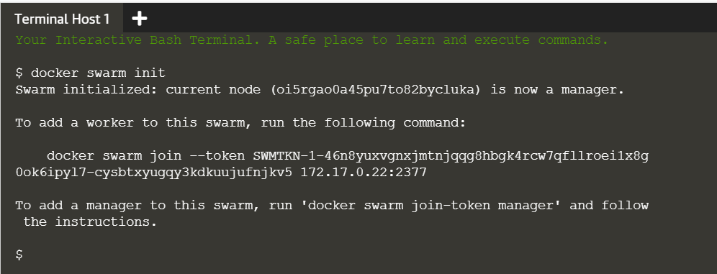

1. Run the command

$ docker node ls

in the master node to view all the nodes in the swarm.

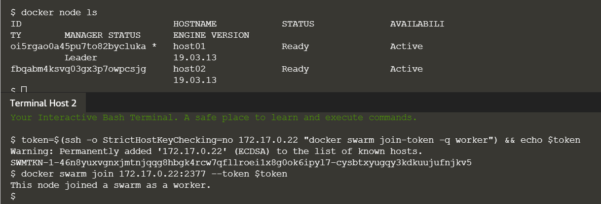

1. Now create a network named Skynet using the command

$ docker network create -d overlay skynet

and list all the available networks using the command

$ docker network ls .



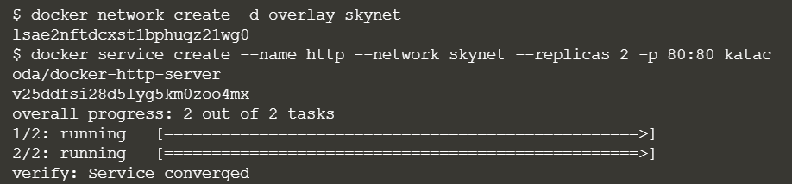Check and list the services using the command

$docker services ls

As of now, there aren’t any services available so the command doesn’t have any listing.

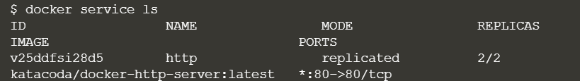

1. Use the command

$ docker service create --name http --network skynet --replicas 2 -p 80:80 katacoda/docker-http-server

here we are creating 2 replicas and assigning them to the nodes.



1. Once the service creation is complete, run the command

$ docker service ls

to list the recently created service.

